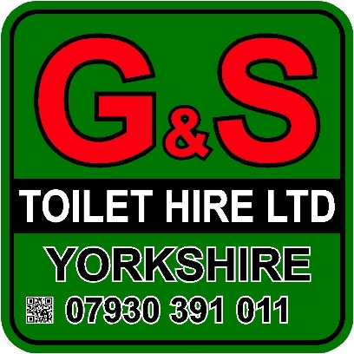

Single Plastic

- WC with toilet seat and lid
- Self-contained units requiring no water, waste or power
- Fully stocked toilets
- Good ventilation
- Anti-slip floor
- HSE Compliant
- Spacious interior design
- Foot operated wash basin and flush system
- Wall dispenser with paper towels
- Restocking and servicing on long-term hire
- Attendant service available (Additional cost)
- Available for long or short-term hire
- Available in green, pink and blue

Specifications
- Height: 2.31 m
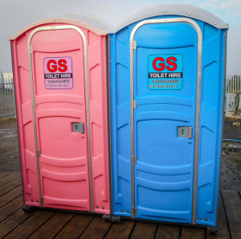
- Width: 1.1 m
- Depth: 1.2 m
- Weight: 90.8 kilos
- Tank Capacity: 227 litres

