Pluto Urinal

- Self-contained units requiring no water, waste or power
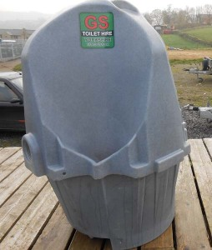
- Long and short term hire available
- These units minimise the queues to cubicle toilets
- Large tank capacities so can be used over 1000 times
- Can be provided with enclosure for privacy (Additional Cost; Limited availability)
- Attendant service available (Additional Cost)

Specifications
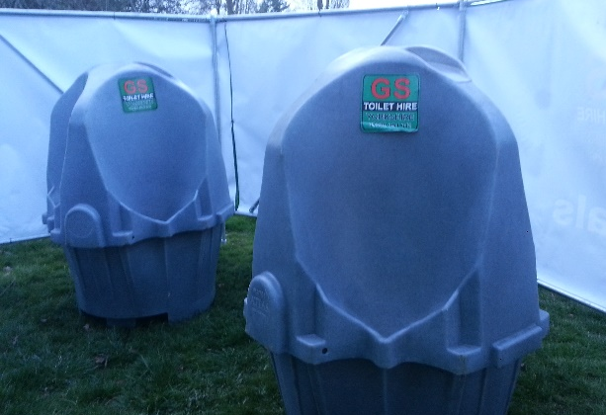
- Height: 1.6 m
- Width: 1.12 m
- Length 1.12 m

Capacity
- Tank Capacity 400 litres (1000+ uses)
- Waste Water:

