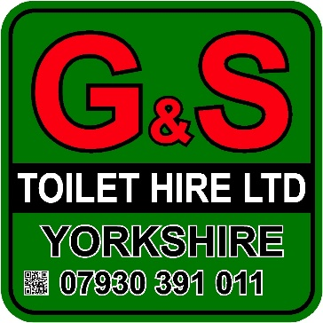

Hand Wash Station

- Caters for up to 1300+ uses
- Two sink unit
- Self-contained units requiring no water, waste or power
- Hand soap and towels provided
- Perfect for events such as Agricultural Shows where contamination may be a concern
- Weekly restock and servicing
- Long and short term hire available
- Hand basins come fully stocked with hand soap and paper towels
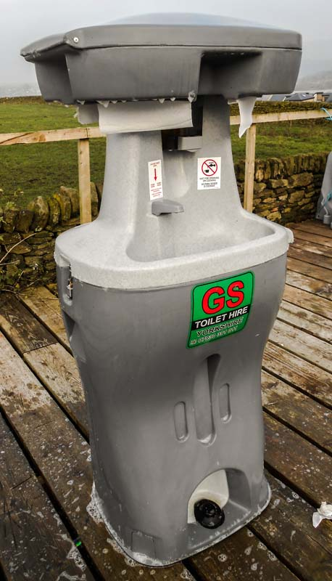
- HSE compliant
- Finished to a high standard

Specifications
- Height: 1.6 m
- Width: 0.7 m
- Length: 0.6 m

Capacity
- Fresh Water: 83 litres (1300+ uses)
- Waste Water:

