Construction Toilet

- WC with toilet seat and lid
- Self-contained units requiring no water, waste or power
- Fully stocked construction toilets
- Good ventilation
- Anti-slip floor
- Spacious interior design
- HSE compliant
- Foot operated wash basin and flush system
- Wall dispenser with paper towels
- Includes weekly restocking and servicing
- Available for long or short term hire

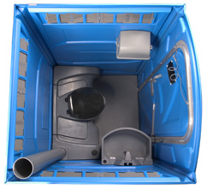
Specifications
- Height: 2.31 m
- Width: 1.1 m
- Depth: 1.2 m
- Weight: 90.8 kilos
- Tank Capacity: 227 litres

