6-Bay Urinal

- Large capacity for over 1000 uses
- Reduces long toilet queues at any event
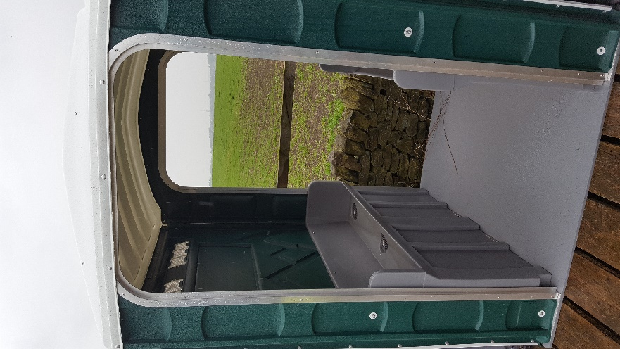
- Privacy screening available (Additional Cost; Limited availability)
- HSE compliant
- Self-contained unit requiring no outside plumbing
- Finished to a high standard
- Available for long or short-term hire
- Weekly restocking and servicing available
- Open at both ends to allow for optimal traffic flow and added ventilation

Specifications
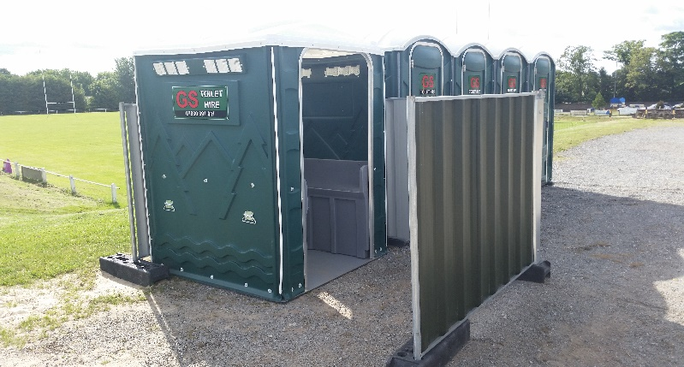
- Height: 2.2 m
- Width: 1.6 m
- Length: 1.6 m
- Tank Capacity per urinal bay: 260 litres
- Total Weight: 136 Kg (300lbs approx.)

