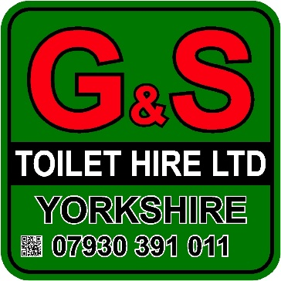

Four Bay Toilet Trailer
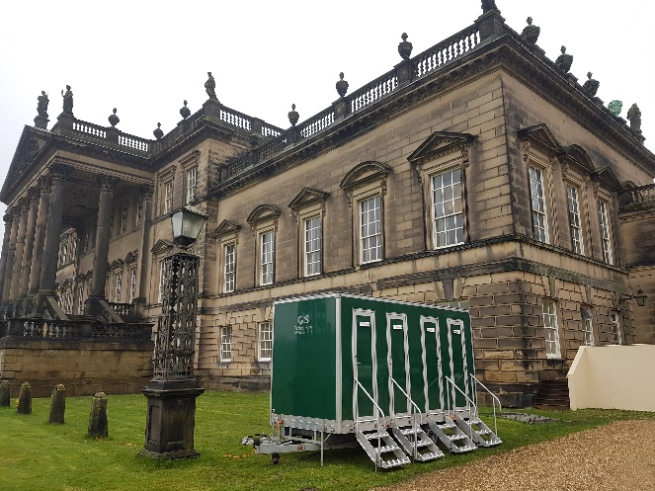
- Luxury toilet hire unit
- High specification interior
- Four private cubicles
- Porcelain basin and WC
- Vanity mirror installed in each cubicle
- Luxury lighting installed
- Caters for up to 200 people
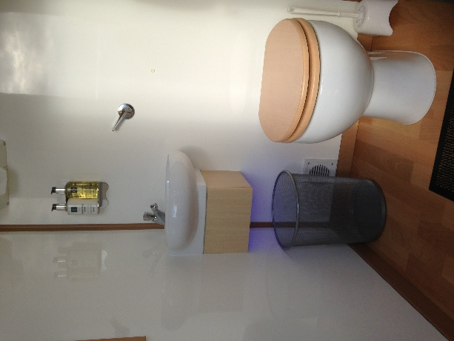
- Hand soap, hand lotion, paper products and towels provided
- Attendant service available (Additional cost)
- On-site service available (Additional Cost)
- Available for long or short-term hire
- Weekly restock and servicing
- Finished to a high standard
- Self-contained, no plumbing required

Specifications
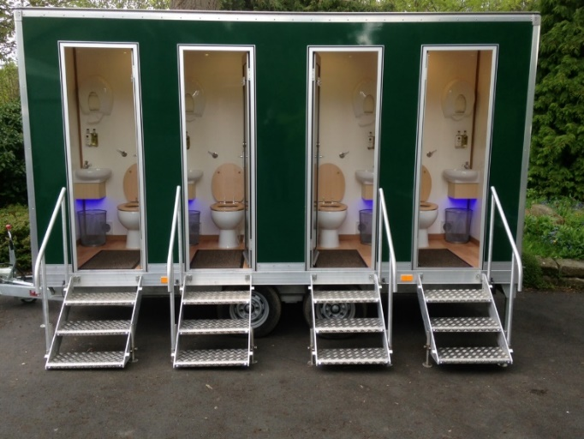
- Height: 2.9 m
- Width: 1.8 m (2.4 m with steps)
- Length: 4.2 m (5.5 m including A-Frame)
Additional Information
- 240v; 3 kw
- 13-amp power required at all times
- Electric Pump

