3+1 Toilet Trailer
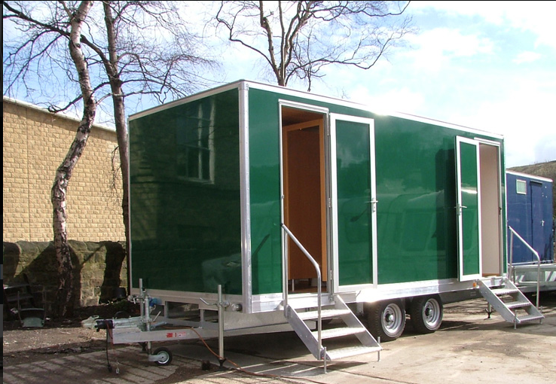
- Luxury toilet hire unit
- High specification interior
- 3 private ladies cubicles
- One private gent’s cubicle
- 2 urinals
- Porcelain basin and WC
- Vanity mirror installed in ladies and gents
- Luxury lighting installed
- Caters for up to 350 people
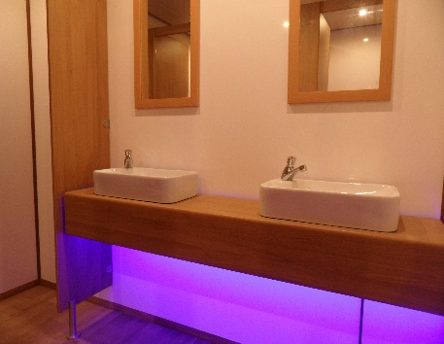
- Hand soap, hand lotion, paper products and towels provided
- Attendant service available (Additional cost)
- On site service available (Additional Cost)
- Available for long or short-term hire
- Finished to a high standard
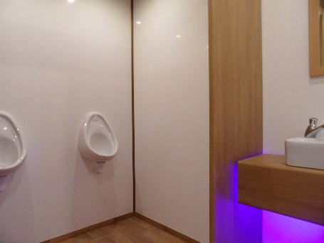
- Self-contained, no plumbing required

Specifications
- Height: 2.9 m
- Width: 1.8 m (2.4 m with steps)
- Length: 5.2 m (6.4 m including A-Frame)
Additional Information
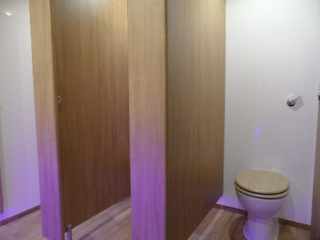
- 240v; 3 kw
- 13-amp power required at all times
- Electric Pump
- Tank Capacity 350 gallons

