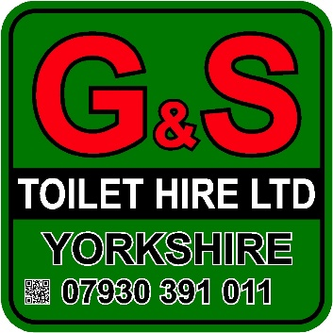

1+1 Trailer Toilet – Twin Axle

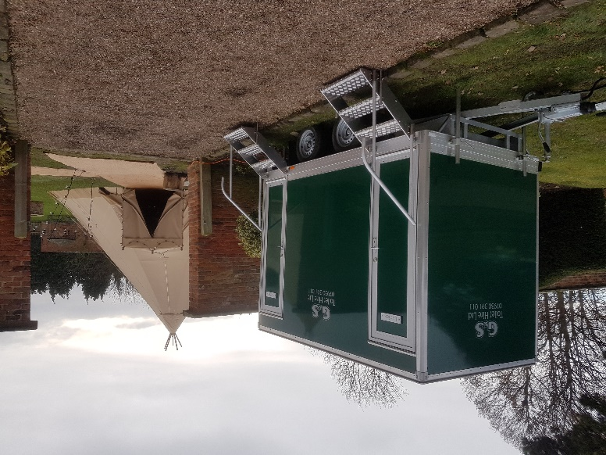
- Luxury toilet hire unit
- High specification interior
- Two private cubicles
- Porcelain basin and WC
- Vanity mirror installed in each cubicle
- Luxury lighting installed
- Caters for up to 120 people
- Hand soap, hand lotion, paper products and towels provided
- Attendant service available (Additional cost)
- On-site service available (Additional cost)
- Available for long or short-term hire
- Finished to a high standard
- Self-contained no plumbing required

Specifications
- Height: 2.9 m
- Width: 1.7 m (2.3 m with steps)
- Length: 2.74 m (3.9 m including A-Frame)

Additional Information
- 13-amp power required for main lights or
- 12v battery provided (provides maximum of 48 hours of power)
- Tank Capacity 175 gallons

